Commodore C64 PSU for the Kradex Z66 Case Rev. 1

Module Description

# Introduction

The goal of this development is a budget 230V PSU for the Commodore C64 (and VIC-20CR) in a budget case (Kradex Z66) with easy to do cut outs. It is based on a transformer for the 9VAC and an AC/DC module for the +5VDC.

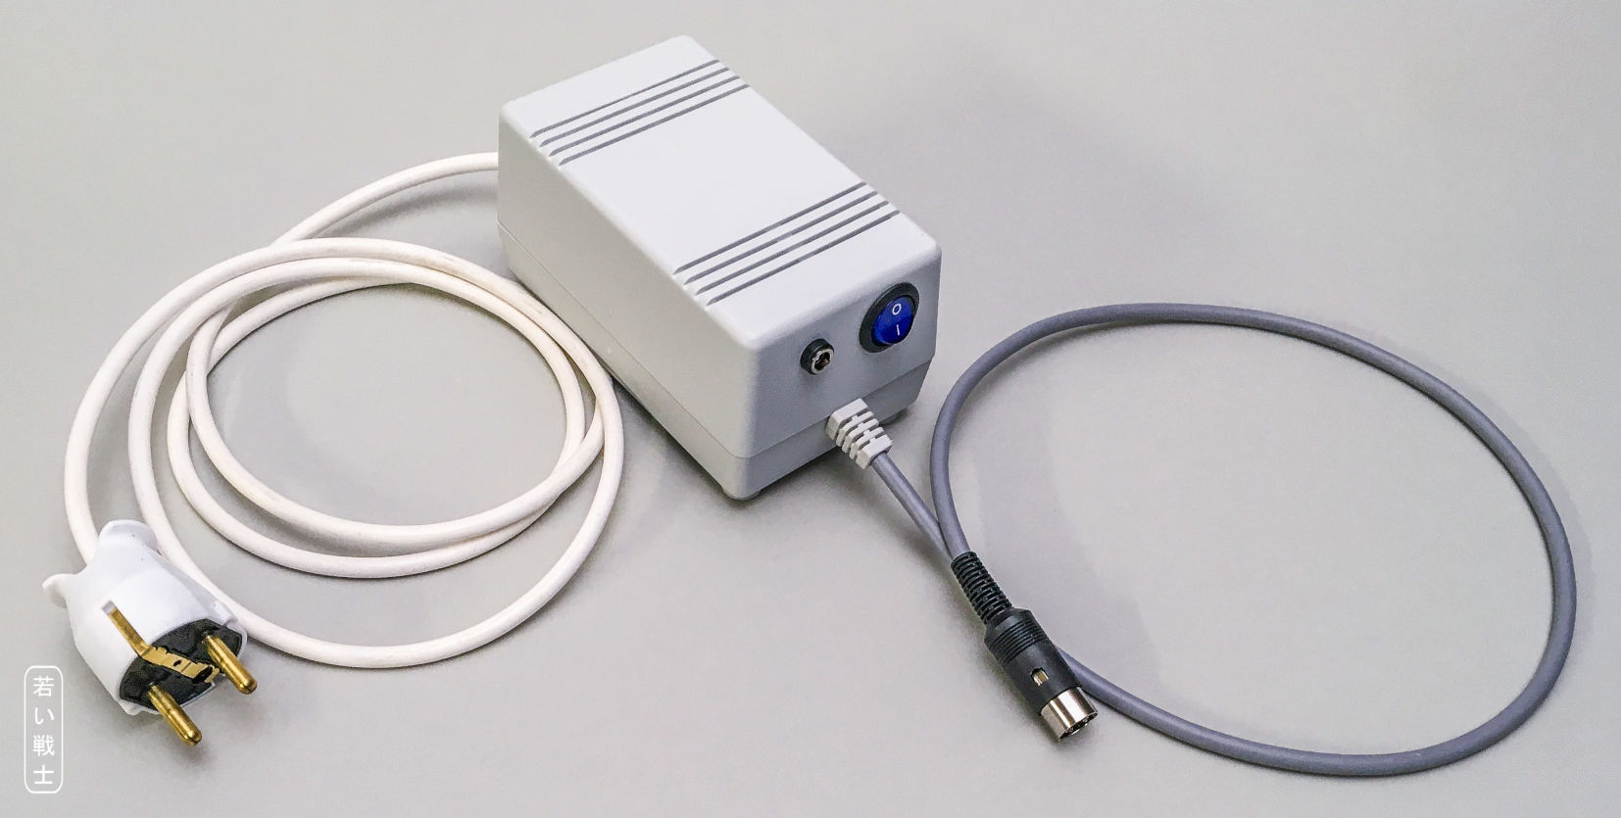

Figure 1: C64 PSU in the Z66 case

There are two options for the transformer:

* BREVE TUFVASSONS: TEZ10/D/9V (10VA/1A fuse)
* Block: VC16/1/9 (16VA/1.6A fuse, not recommended)

It is recommended to use the (cheaper) 10VA type. Since transformers are not regulated, the nominal output voltage is reached at nominal load, below that load, the output voltage is higher. Usually, it is no problem to use a 16VA transformer with the C64, but some of the (oldest) 5 pin/ASSY 326298 boards do not have a heat sink on the linear 5V regulator (7805). Due to the higher output voltage of the transformer, the input of the 7805 is also higher and the regulator tends to overheat (which will first cause video problems). With all other ASSY numbers, even an 18VA transformer does not cause any trouble. The VIC-20 CR (DIN power jack) works well with both transformers. The fuse has to be different for each of the two transformers.

Further on, there are two options for the AC/DC module:

* Mean Well: MPM-10-5 (2A/10W)
* Mean Well: IRM-20-5 (4A/20W)

Both modules have a pretty similar and work well with the C64. The 20W model allows to additionally power a Raspberry Pi/Pi1541 through a barrel connector. The 10W AC/DC module allows to power an additional device like the retroTINK HDMI converter. A USB jack can be installed for this purpose.

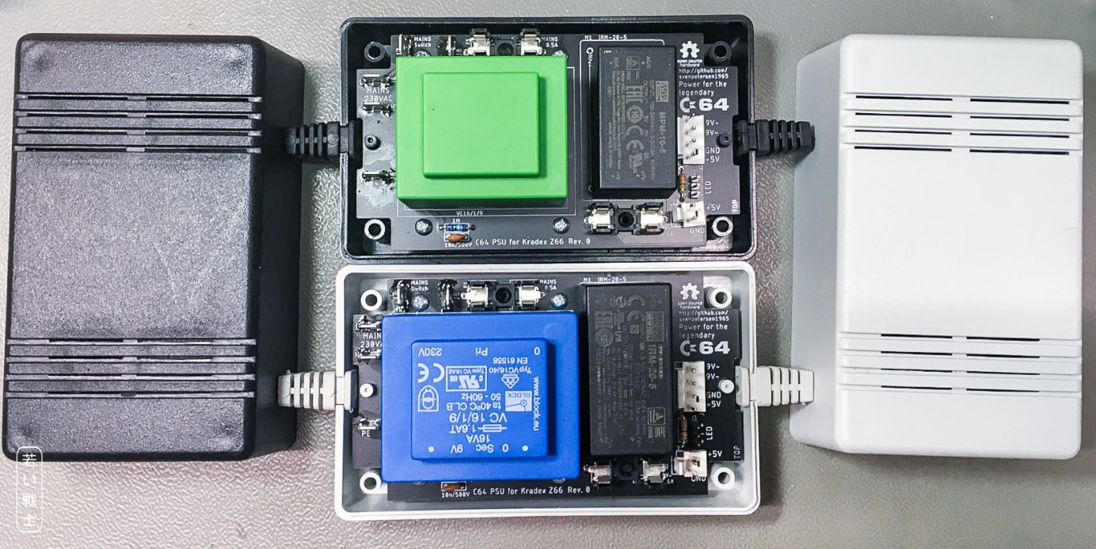

Figure 2: Both versions of transformer and AC/DC-module (Rev. 0)

# Functional Description

The PSU generates +5VDC and 9VAC from the mains voltage of 230V. The +5VDC is the out voltage of an AC/DC converter M1 or M2. The maximum output current depends on the chosen model of this converter. 2A are sufficient (the original PSU generated max. 1.5A). M1 and M2 have wide range inputs and would be capable of 85VAC to 264VAC mains voltage. The 9VAC are generated with a transformer (TR1 or TR2). Thus, the mains voltage should be close to the 230V nominal primary voltage of the transformer.

The protective earth (PE) of the mains cable is connected to GND via an RC-combination (1MΩ in parallel with 10nF/500V). This is to prevent any mains voltage coupled via a stray capacitance between primary and secondary, which is a very common thing with AC/DC converters and switch mode PSUs in general. It also cancels the coupled mains voltage of any PSU in the system, like the power supply of the monitor, the HDMI converter or a Pi1541 disk drive emulator. It is not (yet) a common feature of Commodore replacement PSUs and definitely worth the investment for a fully wired mains connection and the R and the C.

The PSU has an input fuse (500mA, slow blow), a mains power switch (illuminated). The transformer has an output fuse (1A or 1.6A depending on the model).

Since the AC/DC modules have a short circuit, over voltage, overload and over temperature protection, there is no fuse for the +5V. Further, there should be as little voltage drop between the module and the computer. The 5V is pretty accurate (while the original PSUs have a no-load output voltage of about 5.2V to 5.3V). The voltage-drop over a fuse is quite high (over 100mV, depending on the value of the fuse).

Also, the output cable should be as short as possible (50cm to 70cm are recommended).

The mains switch has an input, an output and the neutral (N). Neutral is only required for illuminated mains switches. The N spade connector on the switch is usually colored differently (e.g. brass, while the other two are silver coated).

There is a connector for a power LED. With an illuminated mains switch, it is not required. The 330Ω resistor R1 is sufficient for red, yellow or green LEDs. Blue and white LEDs are usually “bright enough” with this value. R1 is not required, if no power LED is connected.

Since both AC/DC module have a soft start feature, the 5VDC are slightly delayed against the 9VAC. I have never experienced any problem when the C64 was switched on before the PSU was switched on, the recommended power up sequence is PSU first, C64 second.

# Connectors

## Spade connectors

There are 6 spade connectors (6.3x0.8mm) on the board, which are all connected to mains voltage.

|  |  |
| --- | --- |
| Connector | Function |
| J4 | 230V mains L (hot) |
| J5 | 230V mains N (neutral) |
| J6 | PE (protective earth) |
| J7 | Mains switch input lead |
| J8 | Mains switch output lead |
| J9 | Mains switch N (neutral) |

## J1 – Power LED

* Pin header, 1x3 circuits, 2.54mm (0.1”) pitch
* Crimp housing: Dupont crimp housing
* Dupont crimp terminals

It is possible to use a widely available (Ebay, AliExpress etc.) Dupont cable, which can be cut and soldered to the LED.

|  |  |
| --- | --- |
| Pin | Signal |
| 1 | LED + |
| 2 | LED - |
| 3 | LED + |

The pin out of this power LED connector is the same like in a C64 and VIC-20.

## J2 – C64 Power Connector

* Molex KK 396 Header, Vertical, Friction Lock, 4 Circuits, Tin (Sn) Plating:   
  P/N 0026604040
* KK 3.96mm Crimp Terminal Housing, Friction Ramp, 4 Circuits, Natural: P/N 09503041
* KK 396 Crimp Terminal 2478, 18-24 AWG, Bag, Brass Tin (Sn): P/N 08500106.

|  |  |
| --- | --- |
| Pin | Signal |
| 1 | +5V |
| 2 | GND |
| 3 | 9VAC2 |
| 4 | 9VAC1 |

## J3 – Auxiliary +5V Connector

* Molex KK 396 Header, Vertical, Friction Lock, 2 Circuits, Tin (Sn) Plating:   
  P/N 0026604020
* KK 3.96mm Crimp Terminal Housing, Friction Ramp, 2 Circuits, Natural: P/N 09503021
* KK 396 Crimp Terminal 2478, 18-24 AWG, Bag, Brass Tin (Sn): P/N 08500106.

|  |  |
| --- | --- |
| Pin | Signal |
| 1 | +5V |
| 2 | GND |

## Note

If you want to find a **cheaper alternative** for the Molex KK 3.96 connector series, the search term on Ali Express is “CH3.96”. Do not mix Molex crimp terminals with CH3.96 housings and vice versa. They do not fit well to each other.

A suitable **crimp tool** for this kind of connector is e.g., the Engineer PA-20 (1.9/2.3 for wire/insulation crimp) or the IWISS IWS-2820 (the cheaper one - 1.9/2.2 for wire/insulation crimp). Also, the IWISS SN-28B crimp tool produces decent crimps (22-20 notch).

The **spade/FastOn connector**s require a crimp tool for insulated connectors. The color of the insulation is not matter of taste. It marks the suitable wire gauges. With an AWG20/0.75mm² cable, you need a red insulation (0.5mm²-1.5mm²/AWG21-16). The crimp tool has colored dots below the dedicated notch.

# Cable Making

## Lengths

|  |  |  |
| --- | --- | --- |
| Cable | Length | Note |
| Mains | 2 meters, up to your taste | Strip off the (outer) jacket: 8cm, 3xAWG20/0.75mm² |
| Switch L (in) | 16cm | Brown AWG20/0.75mm² |
| Switch L (out) | 15cm | brown (or black) |
| Switch N | 9cm | blue |
| 5V auxiliary | 8cm | AWG20, red and black |
| Power LED | 10cm | AWG24/0.25mm², red and black |
| Output | 50cm – 70cm | Strip off the mantle: 6cm, 4xAWG20/0.75mm² |

## Mains cable

The mains cable is matter of how long you want it to be. There is no critical length within the range of a few meters. Rather make the mains cable longer and the output cable as short as possible.

The cable jacket (outer insulation) has to be stripped off approximately 8cm. The wire insulation should be stripped off 5mm.

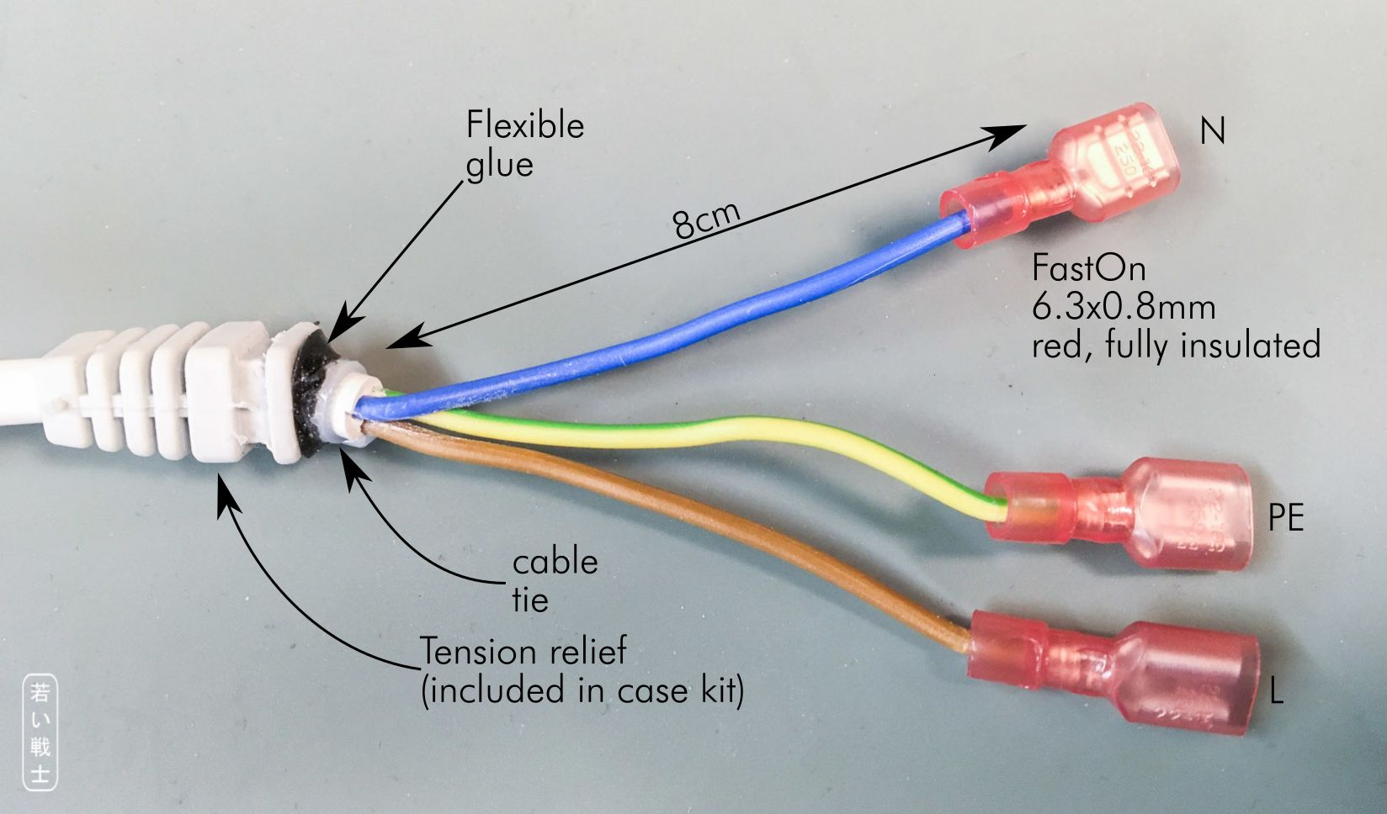

Figure 3: Mains cable

The case comes with two tension reliefs, one for the input (mains) cable and one for the output cable. This will not hold the cable securely. So additional actions have to be taken. A (small) cable tie works pretty well here. Further, gluing the cable into the tension relief with a flexible (silicon) glue is recommended. An epoxy-based glue does not work.

The FastOn crimps should be carried out well and the crimp needs to be tested (pull test). Better order more FastOn connectors than required in the BOM.

The colors of the (inner) wires are (most common):

|  |  |
| --- | --- |
| **Wire** | **Function** |
| brown | Hot (L) |
| blue | Neutral (N) |
| yellow-green | Protective Earth (PE) |

Note: if you are not familiar with this already, you should probably not be building this power supply.

## Mains Switch

The mains switch is preferably a round switch with a 20mm mounting hole. Illuminated switches require a 3rd (N) lead, the input and the output tap should not be confused, so the light goes off, when the switch is off (ion case you do not require a night light). Non-illuminated switches only require two leads and are not directional.

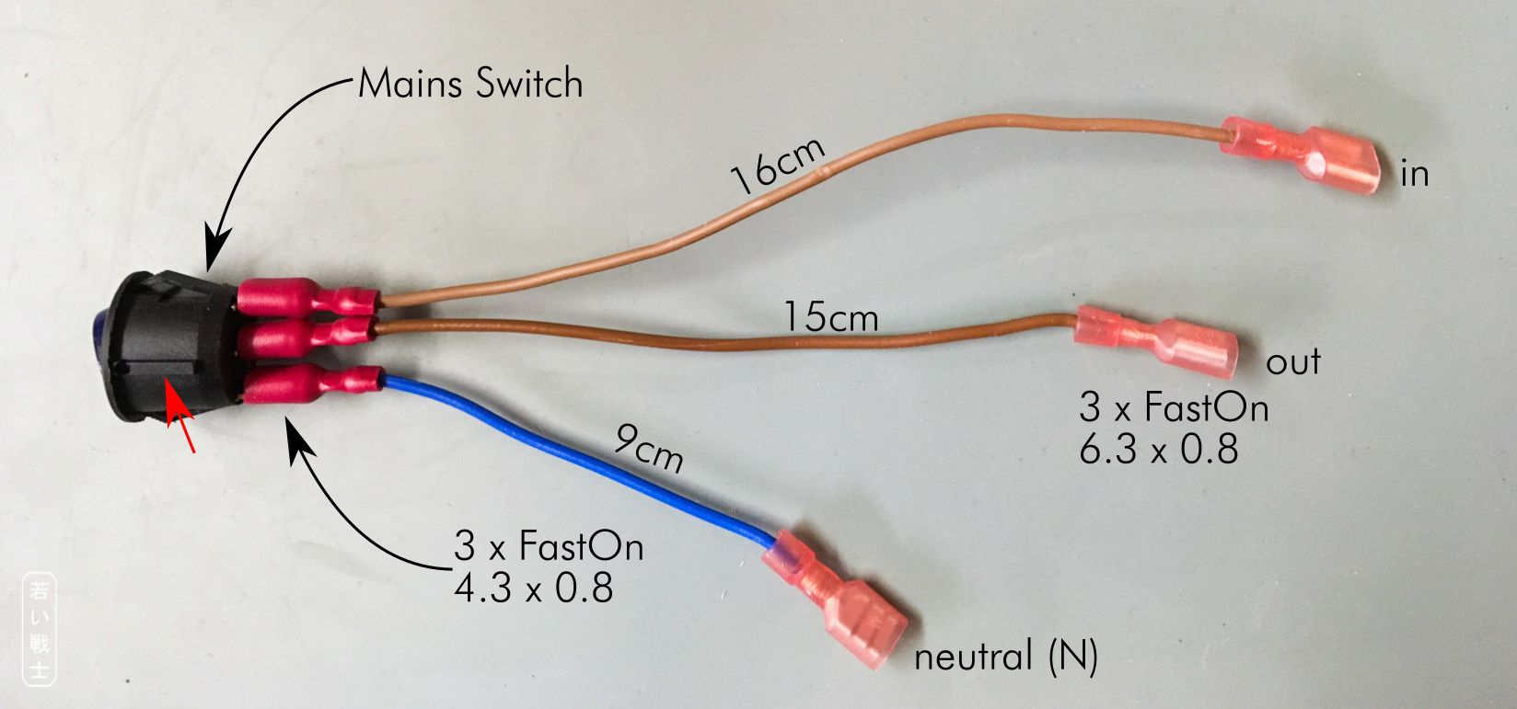

Figure : Mains switch

The anti-twist protection is marked with a red arrow. The N tap is usually marked with a different color. Again, the FastOn crimps should be carried out well and each crimp should be tested.

## Output Cable

The colors of the shown output cable comply with IEC 60757. This does not really matter, but you should choose them in a way, that it can be soldered to the DIN-connector comfortably.

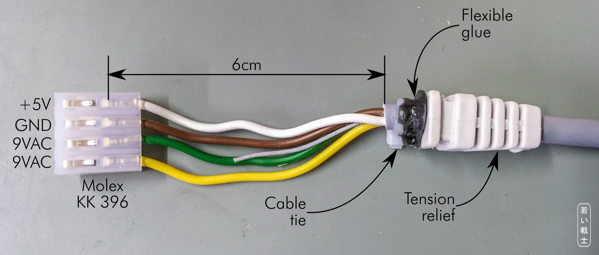

Figure 5: The output cable

|  |  |  |
| --- | --- | --- |
| Pin | Function | Color |
| 1 | +5V | white |
| 2 | GND | brown |
| 3 | 9VAC (1) | green |
| 4 | 9VAC (2) | yellow |

The other end of the cable is the DIN connector. Make sure, that **you do not forget to install the tension relief and the insolation sleeve** of the DIN-jack, before you start soldering the cable to the connector. Millions of cables had to be soldered a 2nd time, because one of these items were forgotten to install (in the proper orientation).

There are several methods to solder a DIN-connector, some stick the connector insert into a potato (rich people use an avocado instead). I prefer using the helping hand for the first solder joint, the remaining solder joints can be performed without, since the insert is already attached to the cable. Do not tin the wire strands before inserting them into the solder cups of the pins. The connectors with half solder cups are easiest to solder. Flux is a great invention and definitely helpful when soldering the DIN connector.

The following table shows the pin out of the C64 (and VIC-20 CR).

|  |  |  |
| --- | --- | --- |
| C64 Power Jack | Pin | Voltage |
|  | 1 | - |
| 2 | GND |
| 3 | - |
| 4 | - |
| 5 | +5V |
| 6 | 9VAC(1) |
| 7 | 9VAC(2) |

Table 1: Power jack of the C64

The 9VAC leads can be swapped if required. It is AC, so the polarity does not matter.

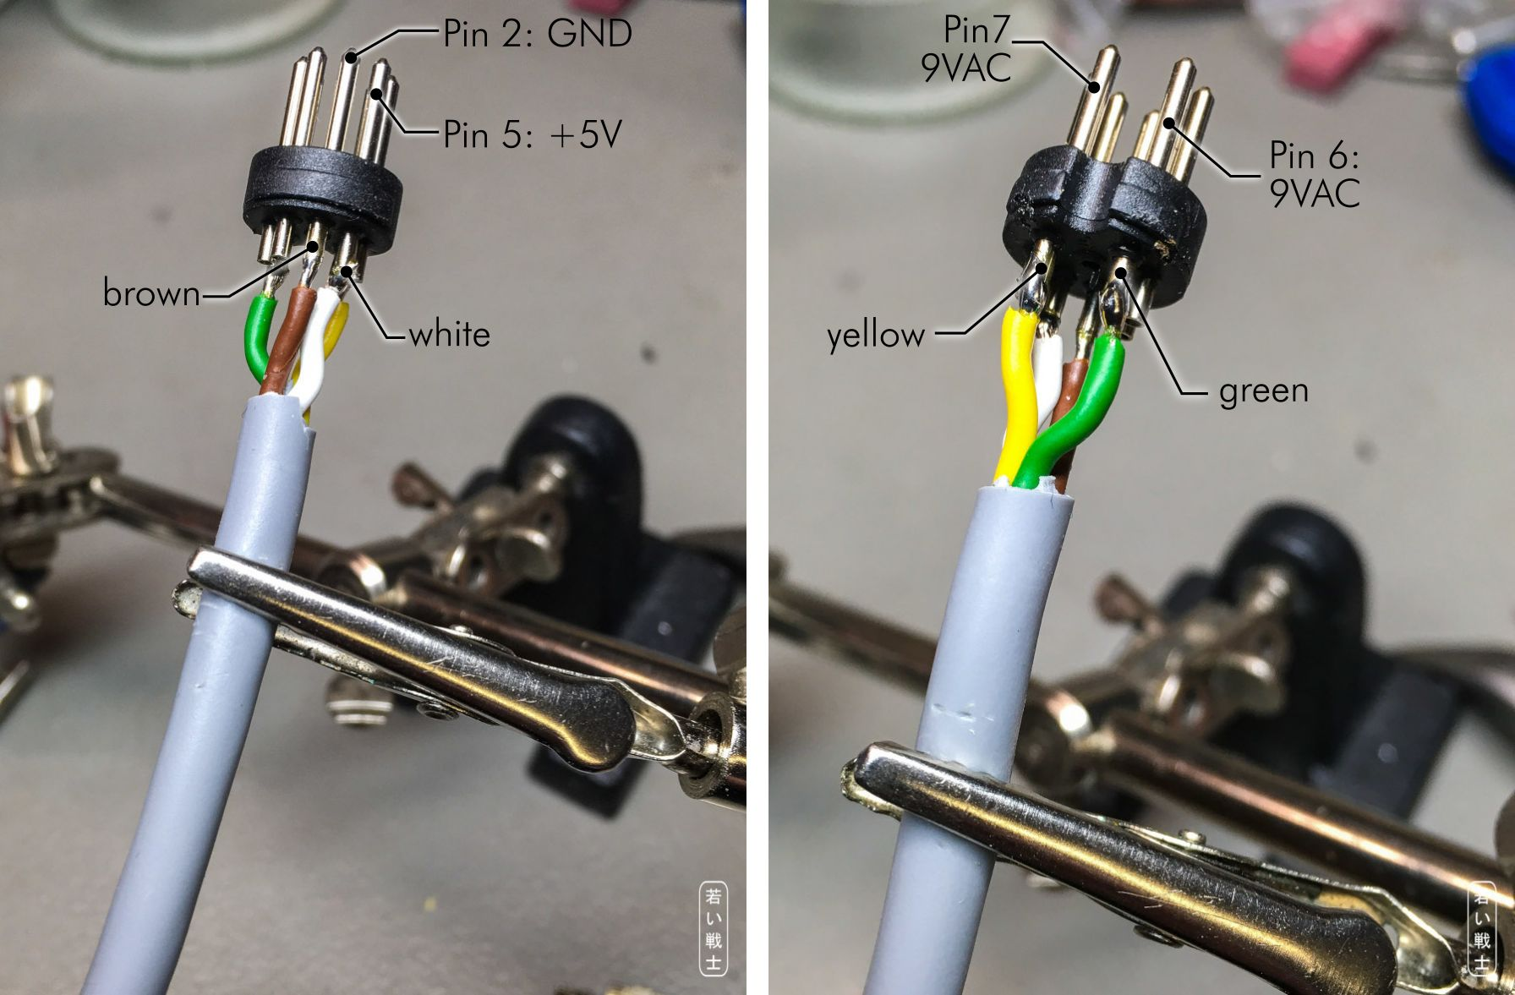

Figure 6: Soldering the DIN-plug (output cable)

## Auxiliary 5V cable (optional)

The auxiliary 5V cable is optional. It makes use of the power reserve of the AC/DC module.

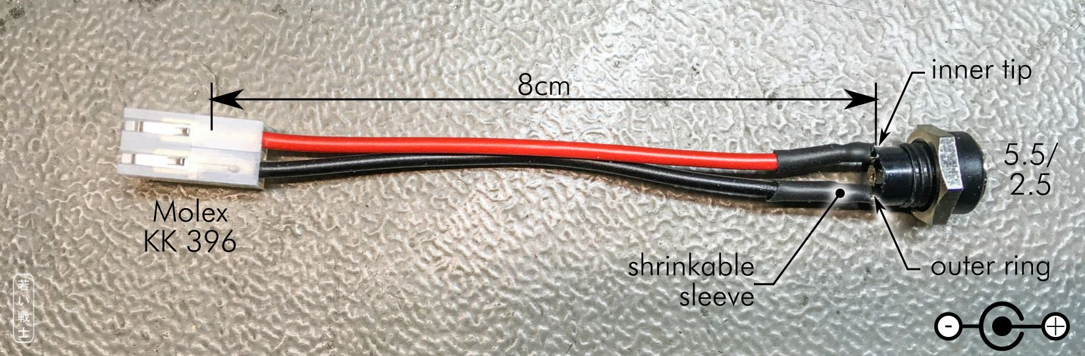

Figure 7: Auxiliary 5V cable (optional)

It might be good not to install the crimp housing before the cable is installed in the case. The crimp terminals can pass the drill in the case, the housing of the connector does not. The terminals can be removed from the housing, but it is better to avoid this work.

## USB-Port (optional)

Alternatively to the barrel jack, a USB jack can be installed to provide auxiliary 5V. This is the choice, if an additional device with a (micro) USB port should be powered. The USB connector is harvested from a slot bracket.

The +5V of the USB-cable is usually a red wire, the GND is the black wire. The data wires are white and green.

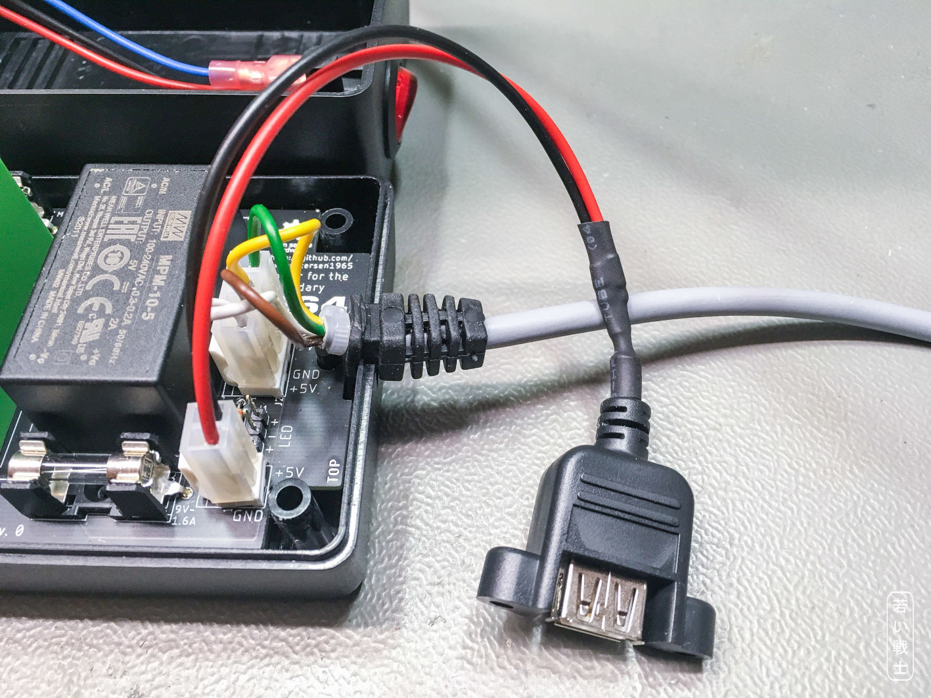

Figure : USB-Port (optional)

The cable making is a bit harder - the cutout is more complicated, too. It is a matter of taste, if this more complicated cable is installed or a standard USB cable is modified with a barrel plug to power a device like mentioned before.

## LED-Cable (optional)

The power LED is optional. Usually, it is not required in case the mains switch is illuminated.

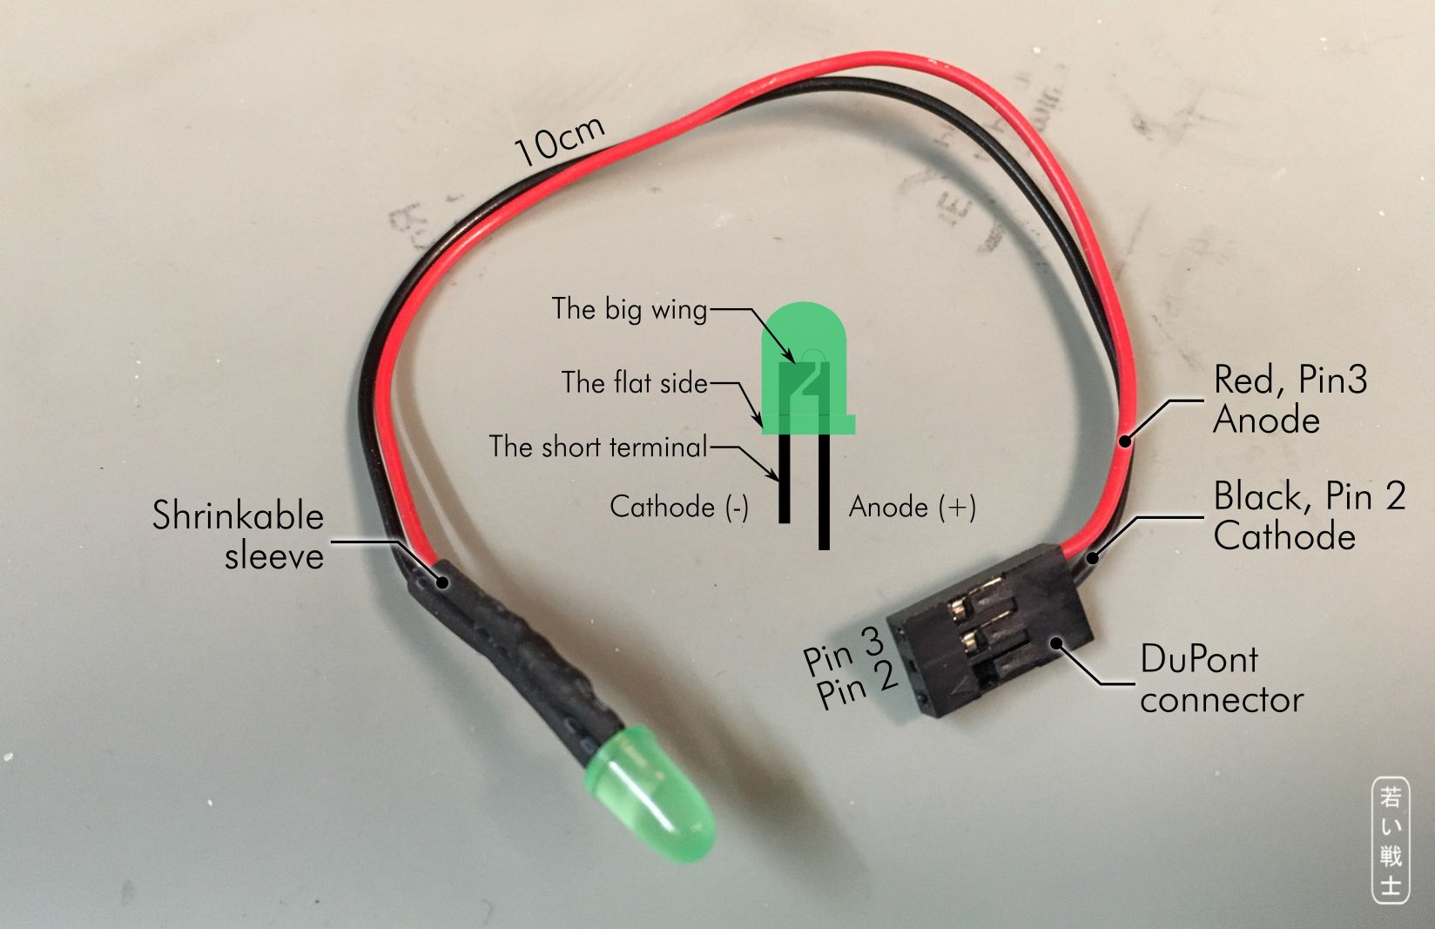

Figure 9: Power LED (optional)

Note:  
For crimping the DuPont terminal, the Engineer PA-20 (1.6/1.6 for wire/insulation crimp) or the IWISS IWS-2820 (the cheaper one - 1.6/1.6 for wire/insulation crimp) is a working choice. The IWISS SN-025 might be the most suitable tool.

# Installation in the Z66 Case

There are only a few cutouts in the case.

1. Mains switch
2. Auxiliary +5V/barrel connector (optional)
3. USB port for auxiliary 5V (optional)
4. Power LED

The mains switch is primarily a 20mm drill and a notch for the anti-twist protection. The auxiliary 5V barrel connector is just a round hole. The diameter depends on the type of connector used for this. It can be measured with a caliper.

There are 1:1 scaled drawings, which can be printed out (in the original scale), cut out, then positioned and fixed to the case. The centers of the holes can be marked with a needle (after that, with a center punch). Also, the corners of the anti-twist notch of the mains connector.

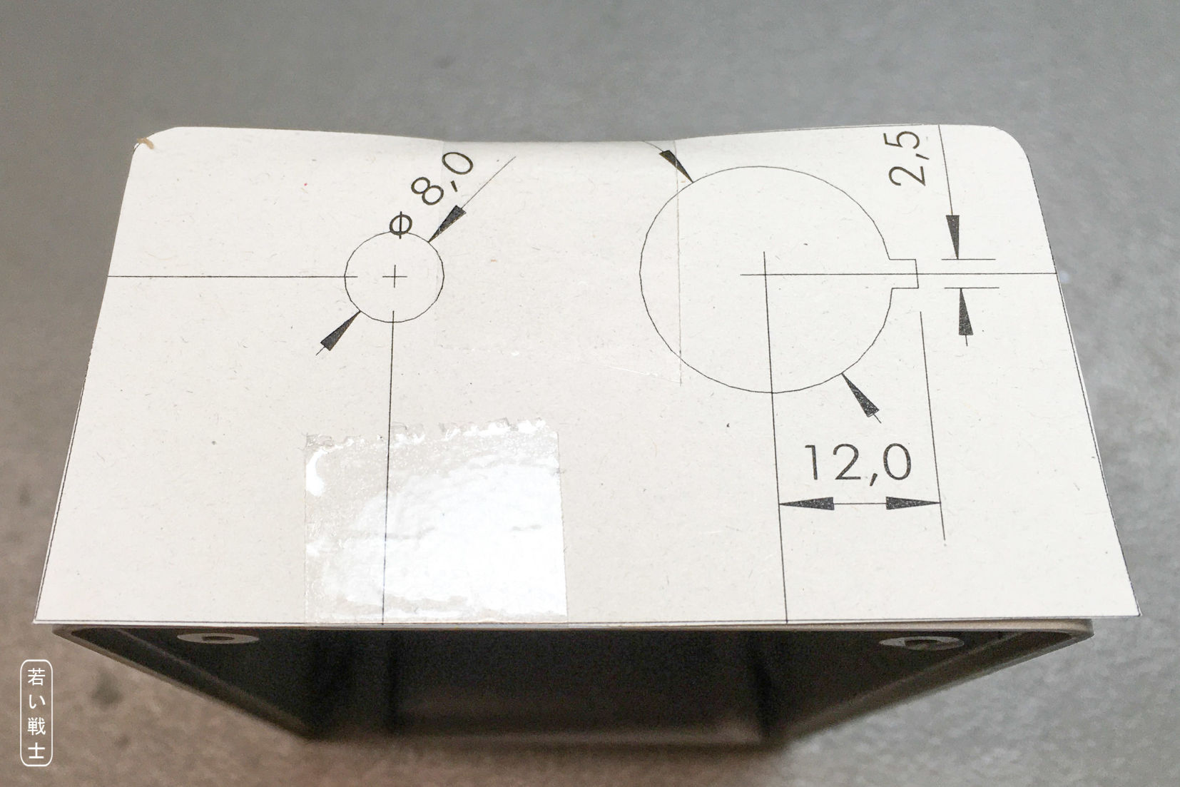

Figure 10: Marking the case with the drawing

The cutout drawing fits better on the case, than it looks in Figure 10, the appearance is matter of the used lens and the proximity. An accuracy of about +/- 0.5mm for the positioning of the paper is suitable. The center of the holes and the corners of the notch can be marked with a needle, first. A center punch only might not the accurate enough.

The 20mm hole for the mains switch is first started with a 4mm drill, which is the smallest diameter of my step drill. Just drill this with a normal drill. Then use the step drill to obtain a 20mm hole.

The notch for the anti-twist protection is then filed with a small square file. Do not file the notch too deep, it would become visible even after the switch is installed.

The diameter of the hole for the barrel connector is not necessarily 8mm, it depends on the connector type.

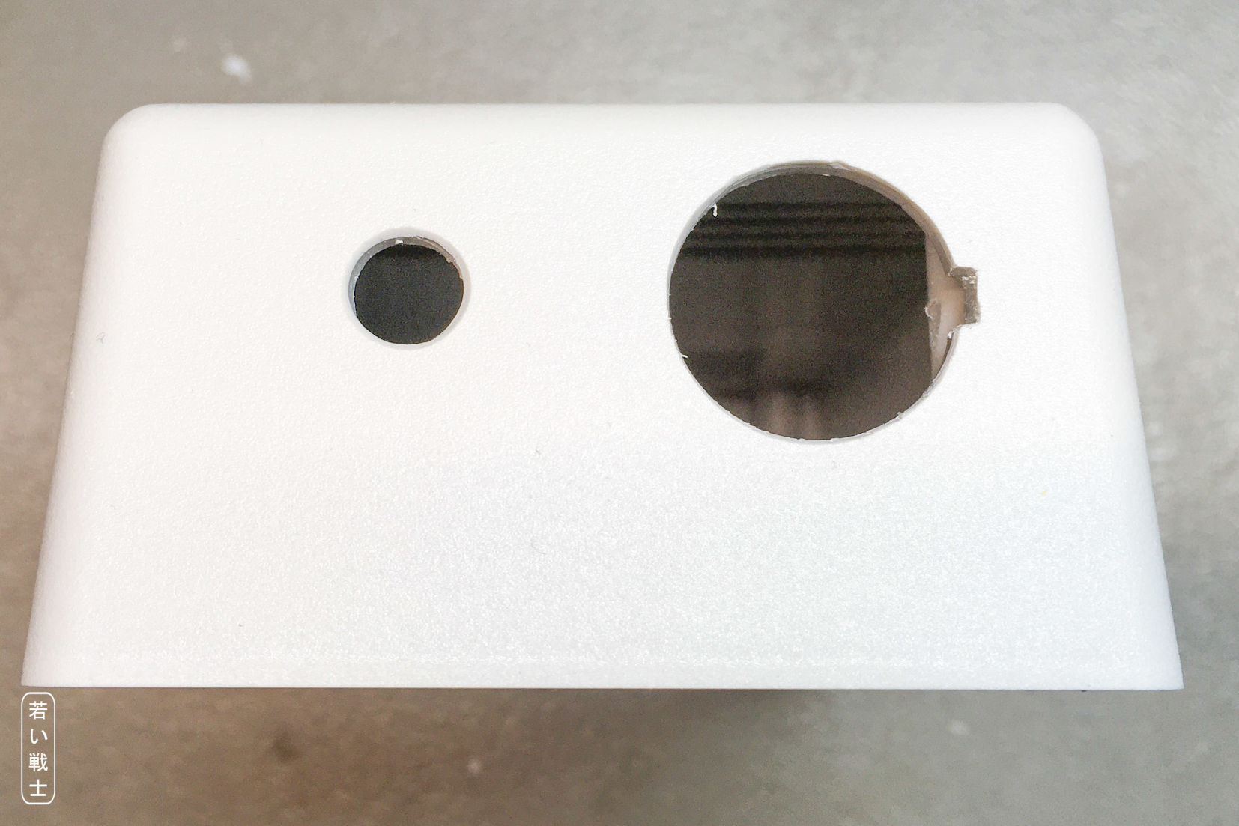

Figure 11: The top shell after drilling

If a power LED is desired, a hole, that fits the LED holder needs to be drilled. The top side might be a good place, a central position close to the front edge is suggested.

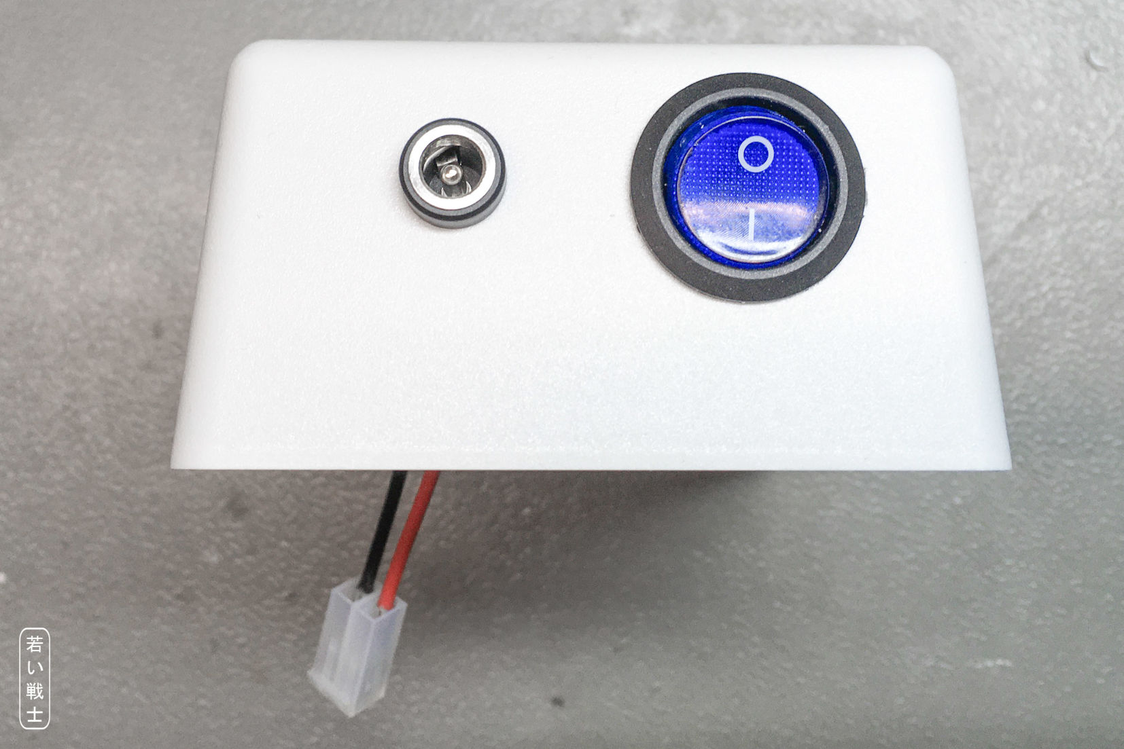

Figure 12: The top shell with the switch and the auxiliary barrel connector installed

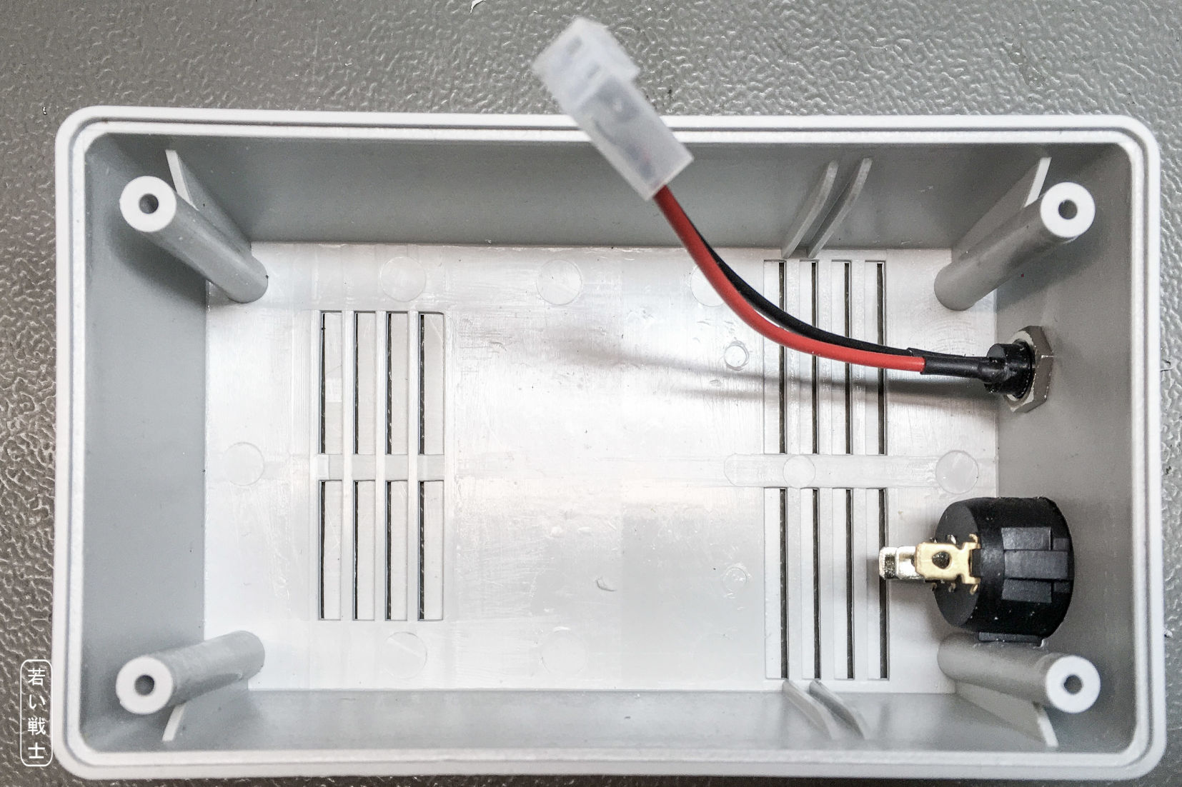

Figure 13: Top shell, bottom view

There is another drawing for the USB port cutout, which can be used as a template. The connector is positioned in a way, that it fits above the AC/DC module.

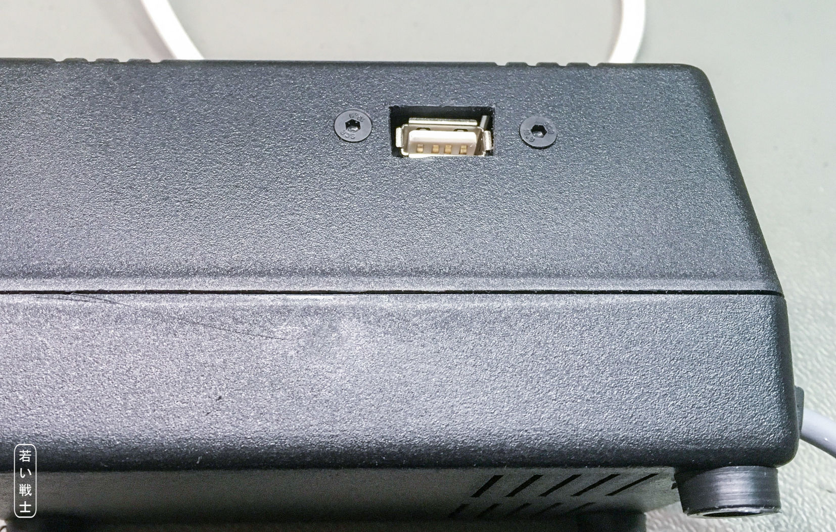

Figure 14: The USB port on the left side of the top shell

The USB connector is screwed to the top shell with two screws (M3). In Figure 14 these are countersunk. Black screws might fit better to a black case, for a light grey case, normal coated screws are a good choice.

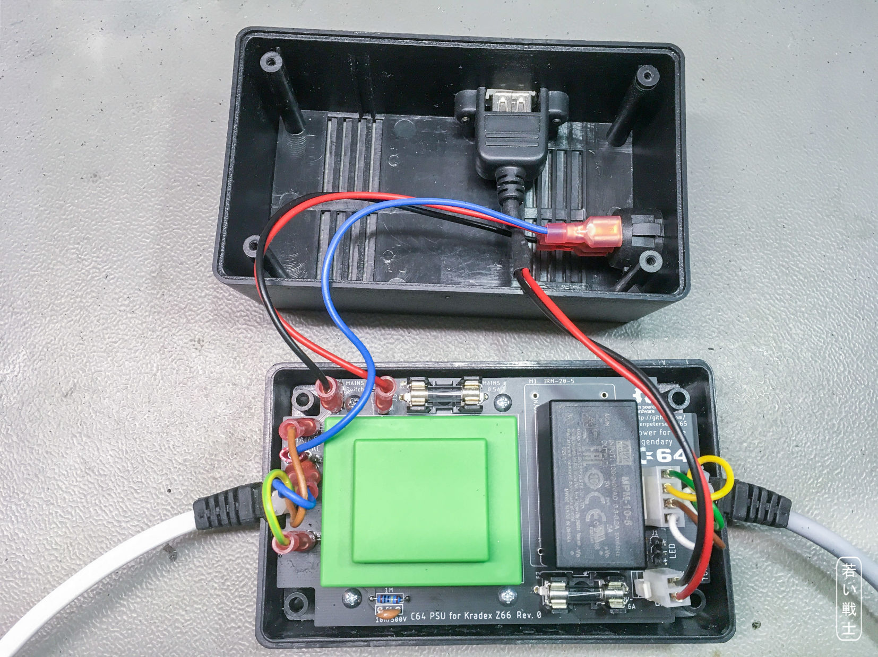

Figure 15: USB cable installed on a Rev. 0 board

## Testing

Before connected to the real computer, it is strictly advised to check the polarity of the +5V and GND on the DIN-Connector. Refer to Table 1: Power jack of the C64. A good way for testing the DIN connector is to connect it to a DIN jack.

In case you need to test C64 PSUs more often, this is a good thing to have.

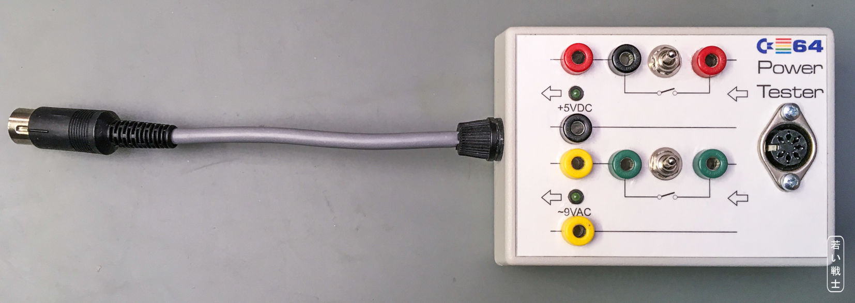

Figure 16: The C64 PSU tester

It is of course not required to have such a test device for building one power supply. The pictures are just put in here as an inspiration. The 4mm lab jacks allow to connect multimeters and load resistors (or an electronic load, if you have one).

Some of the old PSUs have the +5V connected to Pin 4, which is the reason for the 2nd red wire in Figure 17.

The LED for the 9VAC require an anti parallel protection diode. They are not capable of much more than 4V reverse voltage and would get destroyed by the AC.

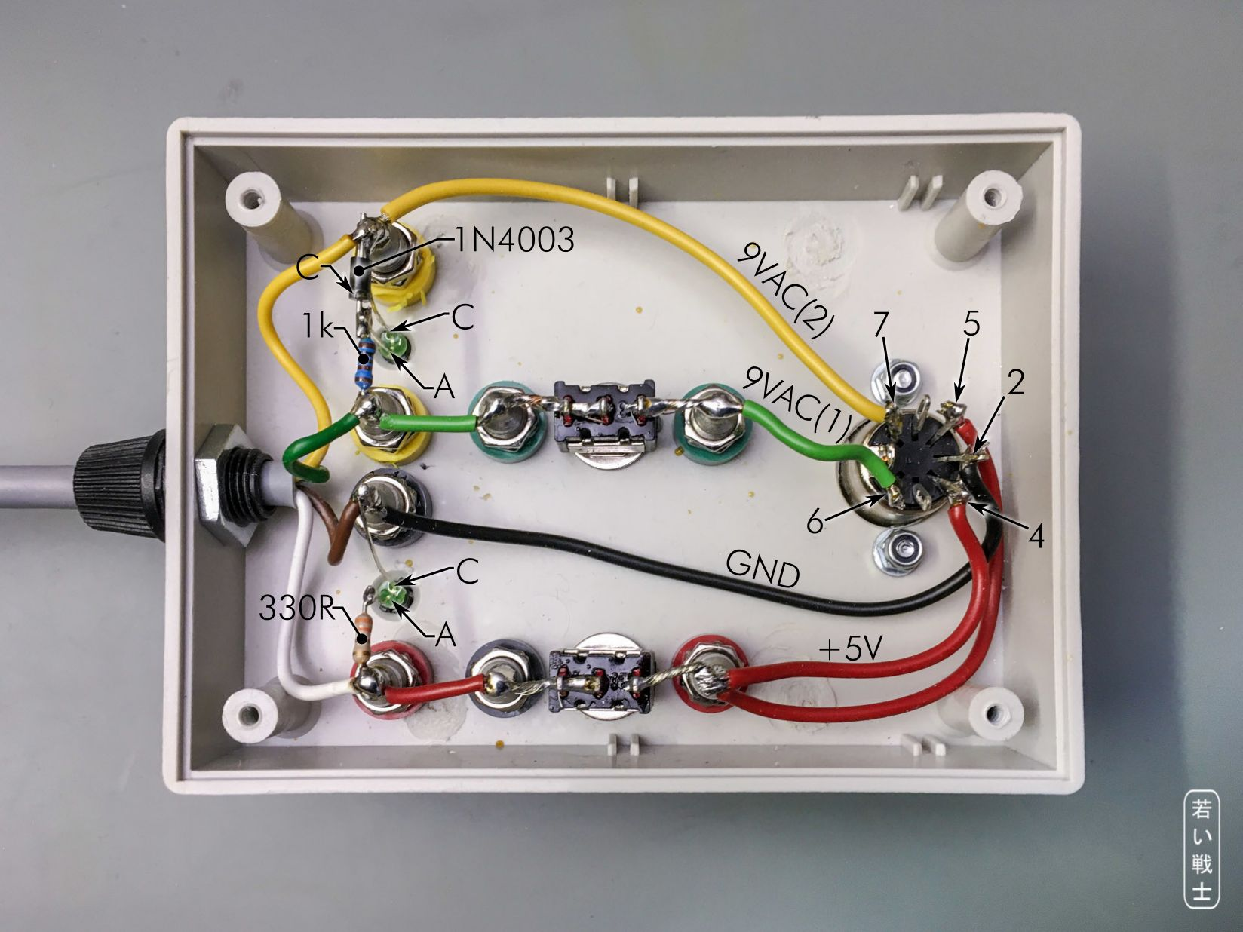

Figure 17: The C64 PSU tester (inside)

# Dimensions

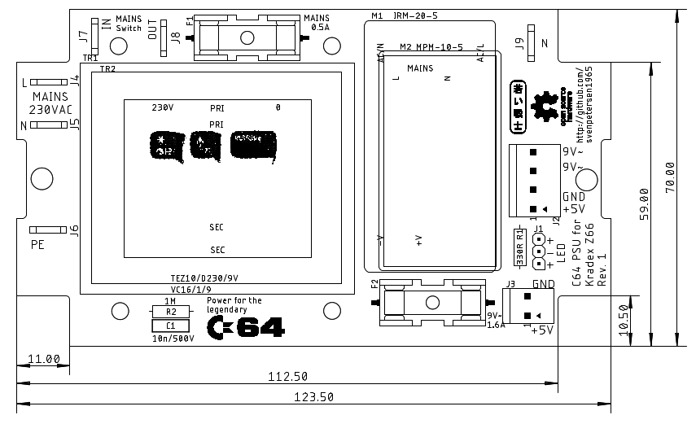

Figure 18: Dimensions of the PCB (not scaled)

# Revision History

## Rev. 0

* Fully functional prototype

## Rev. 1

* FastOn J9 added as N connector for illuminated power switches